**Ahmer Aziz**

**4124**

**Bug Reports:** <https://academybugs.com/find-bugs/>

**Bug 1:**

|  |  |  |  |
| --- | --- | --- | --- |
| **Severity**  Low | **Issue Type**  View Items | **Frequency**  Everytime | **Environment**  All Browser |
| **Action Performed:**   1. Open <https://academybugs.com/find-bugs/> 2. Left click on view 10 result.   **Expected Result:**  The website will show only 10 items when click on view 10 items.  **Actual Result:**  Website shows all the item placed on front page.  **Attachments:** | | | |

**Bug 2:**

|  |  |  |  |
| --- | --- | --- | --- |
| **Severity**  Low | **Issue Type**  Cards size not equally assigned | **Frequency**  Every time | **Environment**  All Browser |
| **Action Performed:**   1. Open <https://academybugs.com/find-bugs/> 2. Scroll down to the items placed on the page.   **Expected Result:**  When we scroll down the page the items placed on the page should have equally width and height.  **Actual Result:**  Some card has equal width and height some have changed  **Attachments:** | | | |

**Bug 3:**

|  |  |  |  |
| --- | --- | --- | --- |
| **Severity**  Medium | **Issue Type**  Item 50 button not working. | **Frequency**  Every time | **Environment**  All Browser |
| **Action Performed:**   1. Open <https://academybugs.com/find-bugs/> 2. Click on 50 item view button.   **Expected Result:**  The page will show the 50 item placed on the page.  **Actual Result:**  The page shows a blur screen popping up a message you found a bug.  **Attachments:** | | | |

**Bug 4:**

|  |  |  |  |
| --- | --- | --- | --- |
| **Severity**  High | **Issue Type**  Item overlap the item price and description. | **Frequency**  Every time | **Environment**  All Browser |
| **Action Performed:**   1. Open <https://academybugs.com/my-cart/> 2. Add item to the cart. 3. Click on view cart. 4. Hover the Mouse on item image.   **Expected Result:**  The image should be zoom on the screen.  **Actual Result:**  The image pop up on the item price and description.  **Attachments:** | | | |

**Bug 5:**

|  |  |  |  |
| --- | --- | --- | --- |
| **Severity**  Critical | **Issue Type**  Item overlap the item price and description. | **Frequency**  Every time | **Environment**  All Browser |
| **Action Performed:**   1. Open <https://academybugs.com/my-cart/> 2. Add item to the cart. 3. Click on view cart. 4. Check out detail will open.   **Expected Result:**  We can change the items number in the update item checkout page.  **Actual Result:**  Item place in the 3rd option did not update the item number.  **Attachments:** | | | |

**Bug 6:**

|  |  |  |  |
| --- | --- | --- | --- |
| **Severity**  Critical | **Issue Type**  Checkout button not working | **Frequency**  Every time | **Environment**  All Browser |
| **Action Performed:**   1. Open <https://academybugs.com/my-cart/?ec_page=checkout_payment#> 2. Add item to the cart. 3. Click on view cart. 4. Check out detail will open. 5. Proceed to check out and submit order.   **Expected Result:**  The Website will ask for payment process.  **Actual Result:**  Submit button not working properly.  **Attachments:** | | | |

**Bug 7:**

|  |  |  |  |
| --- | --- | --- | --- |
| **Severity**  High | **Issue Type**  Checkout button not working | **Frequency**  Every time | **Environment**  All Browser |
| **Action Performed:**   1. Open <https://academybugs.com/anchor-bracelet/> 2. Add item to the cart. 3. Click on view cart. 4. Check out detail will open. 5. Click on Hot item the page will reload again and again.   **Expected Result:**  When click on hot item the page Hot Item will open on the page.  **Actual Result:**  When click on hot item the page start reloading again and again.  **Attachments:** | | | |

**Bug 8:**

|  |  |  |  |
| --- | --- | --- | --- |
| **Severity**  High | **Issue Type**  Twitter incorrect Link | **Frequency**  Every time | **Environment**  All Browser |
| **Action Performed:**   1. <https://academybugs.com/store/fall-coat/> 2. Click on twitter button to follow the website twitter page.   **Expected Result:**  When click on twitter icon on the page the page will redirect to the website twitter page.  **Actual Result:**  Wrong website page open when click on twitter icon on website page.  **Attachments:** | | | |

**Bug 9:**

|  |  |  |  |
| --- | --- | --- | --- |
| **Severity**  High | **Issue Type**  Twitter incorrect Link | **Frequency**  Every time | **Environment**  All Browser |
| **Action Performed:**   1. <https://academybugs.com/store/fall-coat/> 2. Click on myspace button on the website page.   **Expected Result:**  When click on myspace icon on the page the page will redirect to the website myspace page.  **Actual Result:**  Wrong website page open when click on twitter icon on website page.  **Attachments:** | | | |

###### Bug 10:

###### Severity

High

###### Issue Type

Crash

###### Frequency

Every Time

###### Environment

All Browsers

###### Action Performed

1. Open [**https://academybugs.com**](https://academybugs.com/)
2. Click the Find Bugs link on the navigation bar
3. Click on the buttons to show a certain number of results at the top left

###### Expected Result

The selected number of results is displayed according to the clicked buttons

###### Actual Result

The page freezes when clicking on the numbers of results

###### Attachments



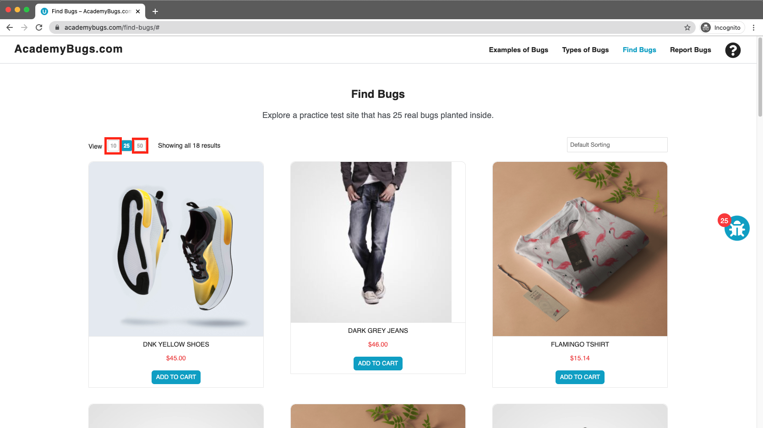

**Bug 11:**

###### Severity

Medium

###### Issue Type

Functional

###### Frequency

Every Time

###### Environment

All Browsers

###### Action Performed

1. Open [**https://academybugs.com**](https://academybugs.com/)
2. Click the Find Bugs link on the navigation bar
3. Open a product
4. Click the twitter share button

###### Expected Result

The twitter share button shows an appropriate page

###### Actual Result

The twitter share button shows an error page

###### Attachments



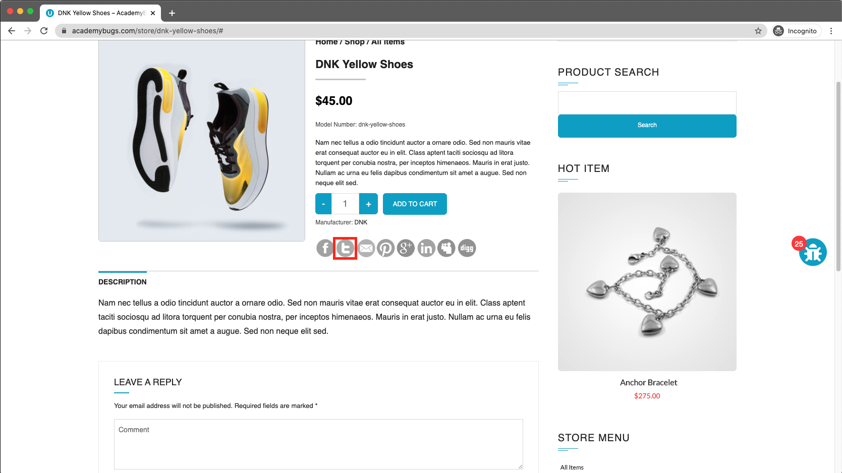

**Bug 12:**

###### Severity

High

###### Issue Type

Crash

###### Frequency

Every Time

###### Environment

All Browsers

###### Action Performed

1. Open [**https://academybugs.com**](https://academybugs.com/)
2. Click the Find Bugs link on the navigation bar
3. Open a product
4. Change the currency in the right side menu

###### Expected Result

The currency is changed as expected

###### Actual Result

The page freezes when changing the currency

###### Attachments



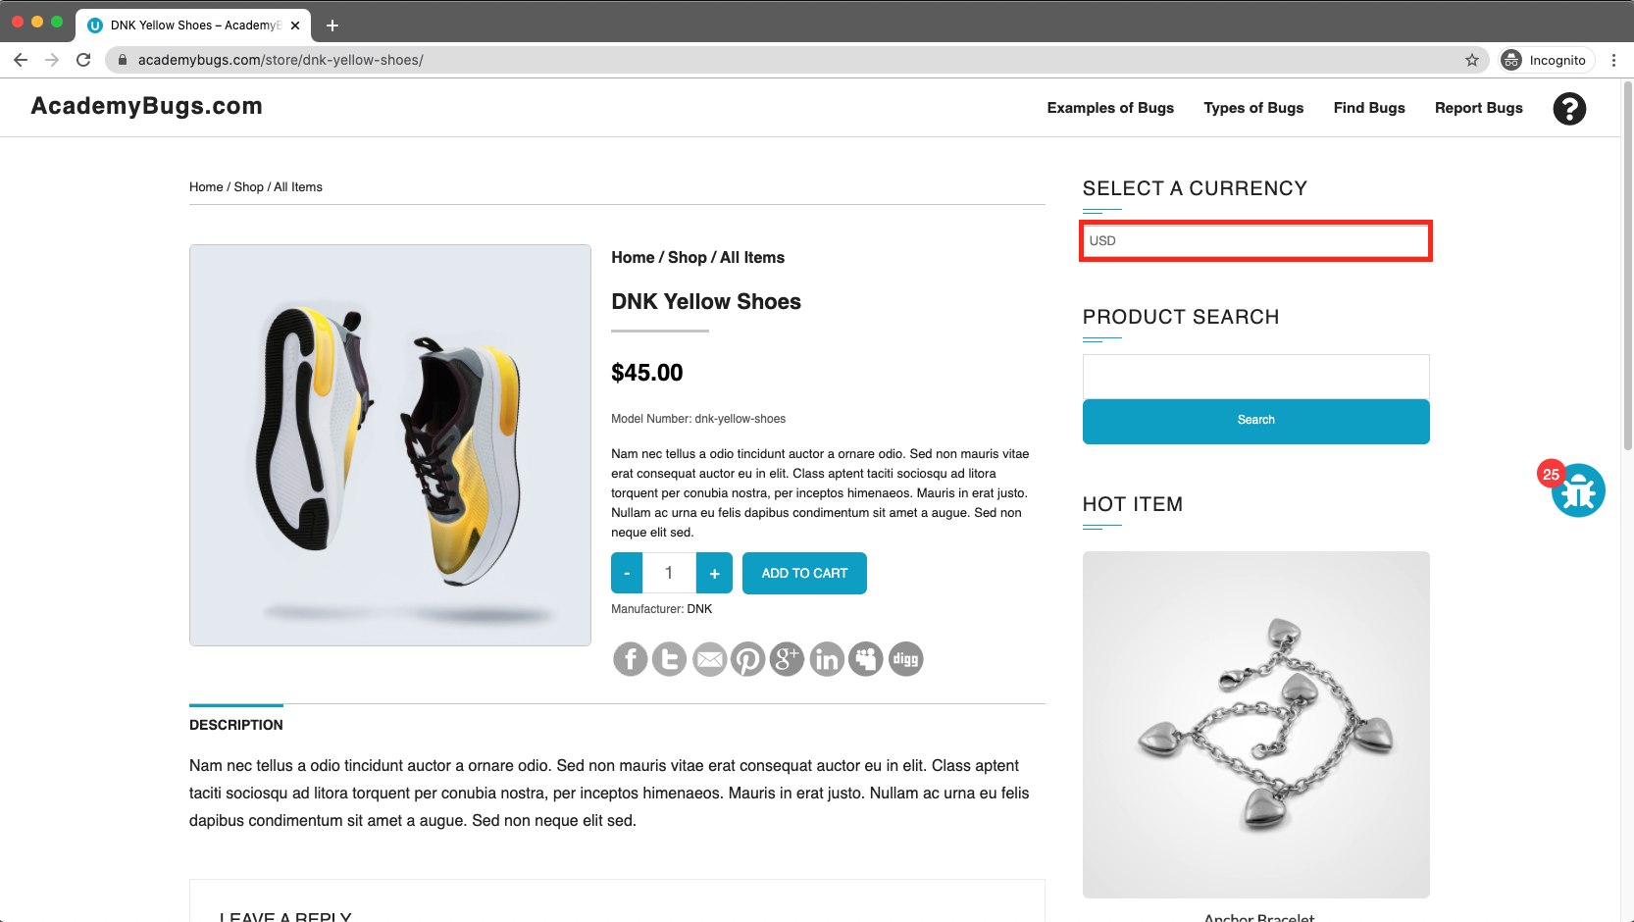

**Bug 13:**

###### Severity

High

###### Issue Type

Performance

###### Frequency

Every Time

###### Environment

All Browsers

###### Action Performed

1. Open [**https://academybugs.com**](https://academybugs.com/)
2. Click the Find Bugs link on the navigation bar
3. Open a product
4. Open the product in the Hot Item section of the right side menu

###### Expected Result

The product in the Hot Item section is displayed

###### Actual Result

The page loads infinitely

###### Attachments



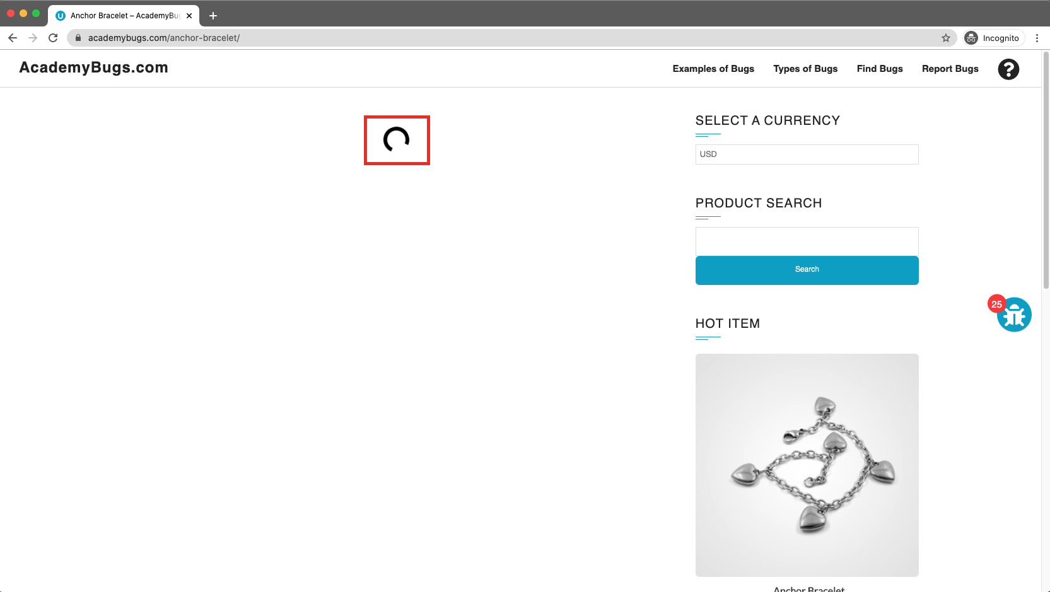

**Bug 14:**

###### Severity

Low

###### Issue Type

Visual

###### Frequency

Every Time

###### Environment

All Browsers

###### Action Performed

1. Open [**https://academybugs.com**](https://academybugs.com/)
2. Click the Find Bugs link on the navigation bar
3. Open a product
4. Scroll down to the bottom of the right side menu

###### Expected Result

The Sign In button is above the footer

###### Actual Result

The Sign In button overlaps the footer

###### Attachments



